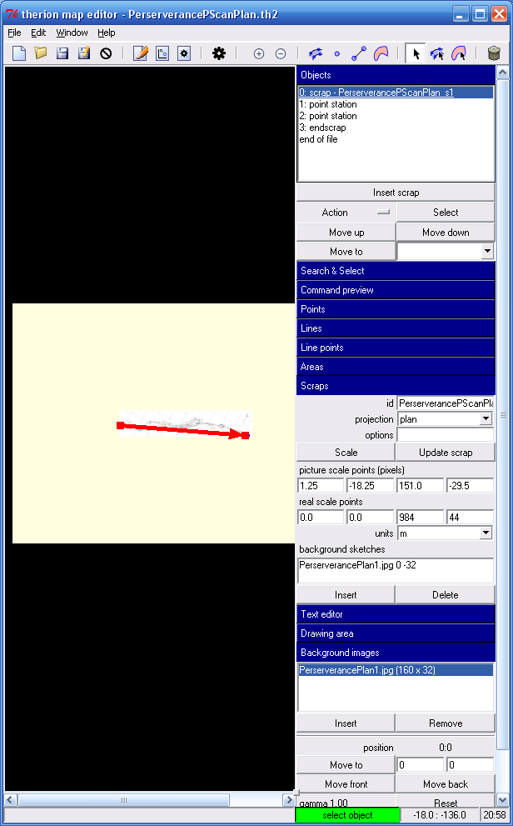
2
1
3
4
5
6
- To Add sketches to the drawing, first create a scrap and give it a projection.
- Select the scrap
- Use the background image insert button to insert an image. It should now be visible in the editor window, you might have to zoom around a bit to find it. The drawing area auto adjust button is useful for this.
- Insert at least two points of type station and in the options text box name them after the stations defined in the survey, in this example the P’INDEX.th file. These should be points for which you can make a pretty good guess at the co-ordinates, either with respect to a co-ord system, or a local arbitrary one that you make up, say relative to the cave entrance.
At this point you can get an output with two survey stations only, or you can go on to trace over the image to produce cartography in the usual Therion way…
- To see the morphed sketch in the output, you need to use the scraps background image insert button. The status bar turns red, and you click on the image displayed in the map window. This adds it to the text box above the button, along with a btm left co-ord that locates it in the map window
- Now, scaling the sketch. Not sure if this is necessary because I’ve used TWO survey stations above, but if I’d used one it would be (as is the case for cross sections). In this case I scaled it – belt & braces perhaps. Drag the two ends of the red line a known distance apart on the image. In this example, 984mE and 44mS. XTherion tells you the picture scale values and you enter the real scale values. Use the update scrap button.

